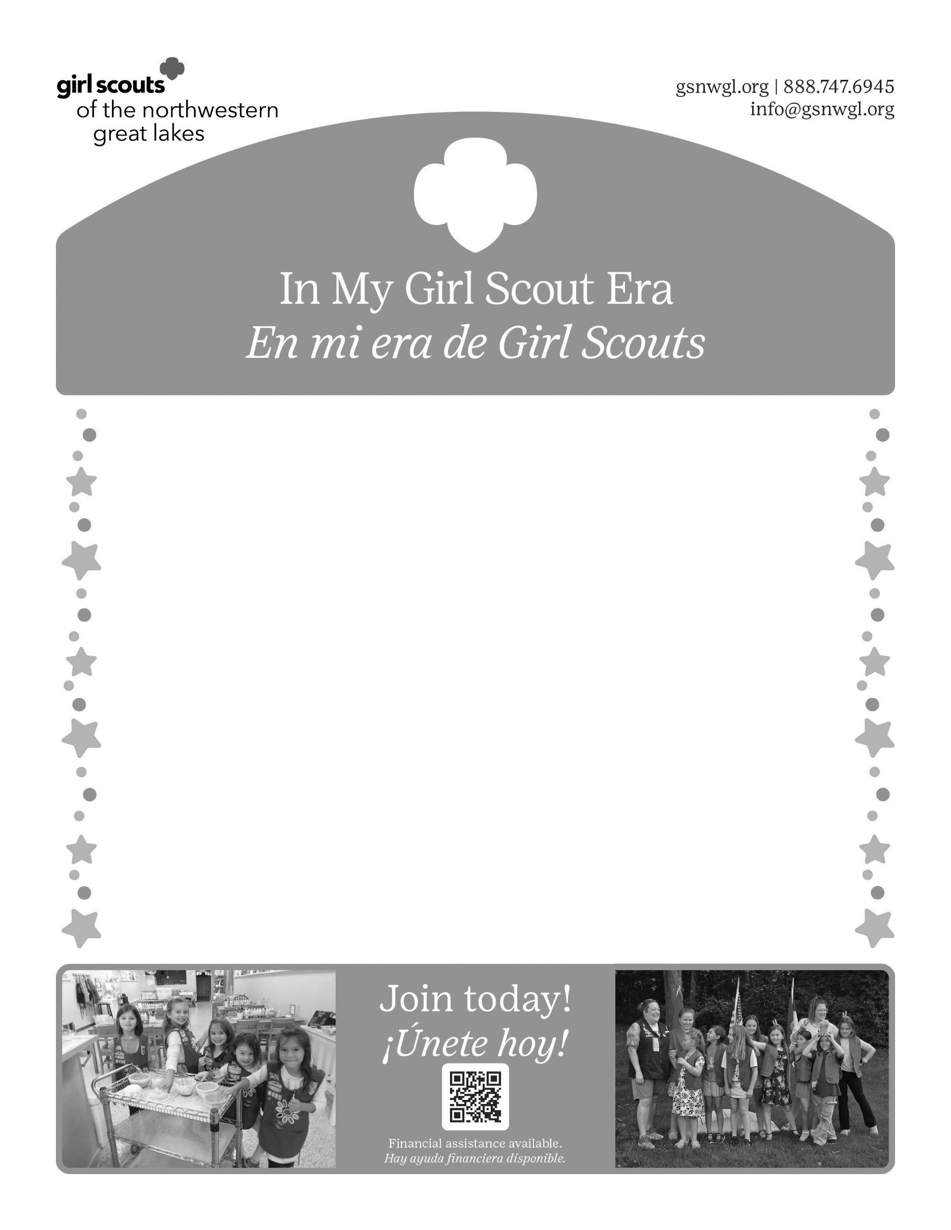
Use Girl Scout Textbook Bold, 14 pt for headers
Use Girl Scout Textbook, 12 pt for subheaders
Use Girl Scout Textbook, 10 pt for text

